REV. |  | Description |  |  |  |  |  | Date
S00 |  | SPEC ISSUE (NEW MODEL) |  |  |  |  |  | 02/21’24
S01 |  | 102A-243197  Change item3.4 “UL20276 18AWG*2+24AWG*1” to “UL20276 20AWG*2+24AWG*1” |  |  |  |  |  | 03/22’24
S02 |  | 102A-244034  Item 1.2.14.5 PPS and AVS |  |  |  |  |  | 04/09’24
S03 |  | 102A-245090  item 2.10.2 Electrolytic aluminum cap life time  刪除''in full load |  |  |  |  |  | 05/15’24
S04 |  | 102A-247338  Change item3.7 Adapter Weight from 210g±2.5% to 204.3g±2.5% |  |  |  |  |  | 07/30’24
S05 |  | 102A-248036  Change Mechanical characteristics item13 from “ External enclosures are subjected to a steady force 250N±10N for a period of 5 sec.” to “External enclosures are subjected to a steady force 12.2kg (120N) for a period of 60 sec.” |  |  |  |  |  | 08/06’24
S06 |  | 102A-248120  Change 1.2.11 Load transient respone  For 9V mode  output voltage shall within +-5% change to 10%  15V : 14.25~15.75 change to 13.5~16.5(15V) |  |  |  |  |  | 08/12’24
 |  |  |  | 台達電子工業股份有限公司  DELTA ELECTRONICS, INC. |  |  | DESCRIPTION :  電氣規格(Electrical Specification)
 | THESE DRAWINGS AND SPECIFICATIONS ARE THE PROPERTY OF DELTA  ELECTRONICS, INC. AND SHALL NOT BE REPRODUCED OR USED AS THE  BASIS FOR THE MANUFACTURE OR SELL OF APPARATUSES OR DEVICES  WITHOUT PERMISSION. |  |  |  |  |  | MODEL NO. :  ADP-65ZW SERIES
 | Date |  | Drawn |  | Design (EE) | Design (ME) | DOCUMENT NAME. :  ES-65ZW SERIES |  | REV.
 | 08/12’24 |  | 邱美淳 |  | 胡育嘉 | 陳俊豪 |  |  | S06
Frame Name:DF-PSLA4V-2R01.DOC SHEET 2 OF 19

MODEL LIST
ADP-65ZW BNA

- ELECTRICAL
  - Input Characteristics:
    - Nominal Voltage
It is normal for 100 ~ 240Vac input AC voltage.
    - Input Voltage Range
The Adapter shall operate from 90 ~ 264Vac.
    - Rated Frequency
It is normal for 50Hz or 60Hz and single phase.
    - Frequency Range
The Adapter shall operate with an input frequency from 47 Hz to 63 Hz.
    - Input Current
1.5A Max at 100Vac input voltage.
    - Inrush Current Limit (cold start)
The I²t shall less then 22% of the Fuse.
    - Efficiency (Warm Up)
      - Nominal input voltage, maximum load and measured at the end of DC cable.
(Warm up after 30min )
Vout | Efficiency
5 | 79.3%
9 | 84.5%
15 | 86.5%
20 | 87.0%
      - Active mode efficiency:
average efficiency of 25%,50%,75% and 100% load tested at 115Vac/60Hz and 230Vac/50Hz.(Warm up after 30min)
Vout | Efficiency
5 | 82.385%
9 | 87.62%
15 | 88.852%
20 | 89.00%
The efficiency at 10% loading shall be more than 76.835% (5V); 82.295%(9V) ; 83.853%(15V) 84%(20V) measure at 115Vac/60Hz and 230Vac/50Hz
    - No Load Power Consumption
5V only: Maximum non-load power consumption is less than 0.075W at 115Vac/60Hz and 230Vac/50Hz
    - Power saving requirement
115Vac/60Hz , 230Vac/50Hz. (20V)
Ootput Voltage (V) | DC POWER(W) | AC Spec. Power ( W )
20V | 18.0 | <21
20V | 11.0 | <14
20V | 5~6.5 | Eff.>80%
20V | 3 | <5
20V | 1.65 | <3
20V | 1.5 | <2.2
20V | 1 | <1.6
20V | 0.25 | <0.47
5V | 0.15 | <0.28
  - Output Characteristics:
    - Rated Voltage
The rated output voltage is specified at 5V / 9V / 15 / 20V.
    - Voltage Range
The output voltage range
Vout | Voltage Range
5 | 4.85~5.5V
9 | 8.55~9.45V
15 | 14.25~15.75V
20 | 19~21V
    - Current
This Adapter can work from 0 A to 3 A (5V~15V) and 0 A to 3.25 A (20V) output voltage is in section 1.2.2 specified range.
Vout | Load
5 | 0~3A
9 | 0~3A
15 | 0~3A
20 | 0~3.25A
    - Output Ripple and Noise
Output ripple voltage is 180mV / 200mV / 300mV / 300mV peak to peak.
Measured methods:
T1. Performed by 20M Hz bandwidth in oscilloscope.
T2. Applied 0.1uF high frequency capacitor and 10uF electrolytic capacitor across output connector terminals.
T3. Measured at the end of DC cable.
T4. 47Hz and 63Hz tested at 90Vac and 264Vac. @ 25℃
Vout | Ripple and Noise
5 | 180mV
9 | 200mV
15 | 300mV
20 | 300mV
    - Turn On delay time
The Adapter shall switch on in less than 3 seconds (5V only) at input voltage is 100Vac~240Vac.
    - Hold –up time
The output voltage shall be sustained 5mS (20V only) within regulation requirement after loss 100Vac and maximum load.

    - Rise time
DC output rise time from 10% to 90% of output voltage shall be less than 40mS (5V only) at nominal line and maximum load.
    - Overshoot
The output overshoot at turn on shall not exceed 10% of normal voltage value with or without the load connected.
    - Peak load (20V/15V only)
The adapter shall support below loading condition without and damage, safety issues and protection happen. The output voltage shall more than 18.3V (20V mode) / 13.5V (15V mode) at input voltage is 100-240Vac/50Hz-60Hzin 25℃.
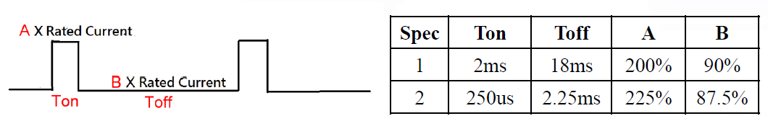

    - Surge load (20V/15V only)
The adapter shall support a surge load with 120% of maximum load for 1min , maximum load for 9min and Output Voltage more than 18.5V /13.7V at input voltage is 100-240Vac in 25℃.
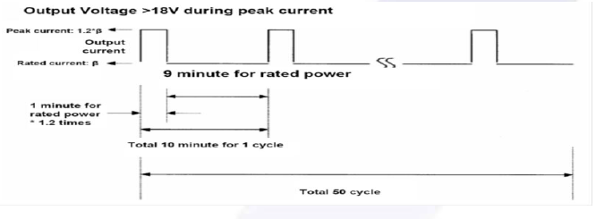
    - Load transient response
(1) For 5V Output and 9V output must to meet condition 1 and condition 2
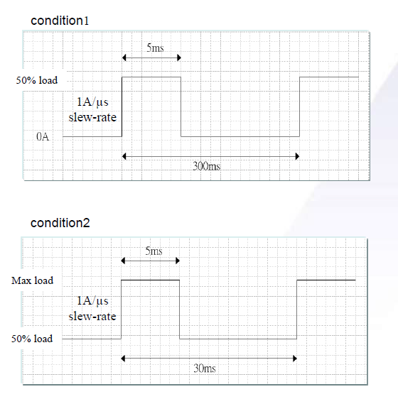
For 5V mode
Output voltage range:
-Max . 5.8V
-Min. 4.6V

For 9V mode
Output voltage shall within +/-10%

(2) The adapter must within regulation when applied a step load from 0.05A to 100% load at
2.5A/us slew rate , 50% Duty cycle , Frequency be operated 100Hz/100KHz in 25℃.
The output voltage will be performed 13.5~16.5(15V); 19 ~ 21V(20V)
    - Hot Plugging
Plugging a live AC adapter into the system with 100uF (for 5V Mode) and 1000uF (for 15V/20V Mode) capacitance shall not trigger any protections or cause the adapter to shut down
    - Voltage Dips (for 20V Mode)
-Follow the test item “ >95% reduction , 0.5 period ” in IEC 61000-4-11 Standard. -The output voltage shall be more than 14.5V at the below condition :
(a) AC Input = 100Vac/50Hz
(b) Load =33W~ 45W constant power (instead of constant current)
-Follow the test item “30% reduction, 25 periods” in IEC 61000-4-11 Standard. -Criteria: A
(a) AC Input = 100Vac/50Hz
(b) Load = 33W~ 45W constant power (instead of constant current)
    - Protection
      - Over Voltage Protection
The output shall be protected to AC latch-off at over-voltage condition. That might be return to normal state by AC reset.
Vout | OVP
5 | 7.5V
9 | 13.5V
15 | 20.25V
20 | 27V
      - Over Current Protection
The adaptor shall be DC latch-off with 60ms deglitch time. (It will enter into normal condition by re-plug in DC plug)
Vout | OCP
5 | 3.3~3.6A
9 | 3.3~3.6A
15 | 3.9A~5A max
20 | 3.9A~5A max
      - Short Circuit protection
Output can be shorted without damage. The adaptor shall be DC latch-off. (It will enter into normal condition by re-plug in DC plug)
      - Over Temperature Protection
No deformation and no discoloration on case and will be shut down (AC or DC latch-off). That will be return to normal state by re-plug in DC plug
1.2.14.5 PPS and AVS function
Item | Vout | Load
PPS | 5V~21V | 3A
AVS | 9V~14.9V | 3A
AVS | 15V~20V | 3.25A

- Environmental
  - Temperature
2.1.1 Operating
The AC Adapter shall be capable of operating at full load with an ambient temperature range of 0 ℃
to +40℃.
2.1.2 Shipping/Storage
The AC Adapter shall be capable of withstanding ambient temperature from -30℃ to +80℃.
2.2 Humidity
2.2.1 Operating
The AC Adapter shall be capable of operation in relative humidity of 5% to 90% relative humidity,
non-condensing.
2.2.2 Shipping/storage
The AC Adapter shall be capable of withstanding ambient relative humidity of 5% to 95% relative
humidity, non-condensing.
2.3 Immunity
2.3.1 Lightning Surge Immunity
This is to follow the norm of IEC-1000-4-5 Level 3 requirements.
L-N +-1.5KV/1.2 * 50uS 5 times No function error.
L-FG, N-FG +-2.5KV/1.2 * 50uS 5 times No function error.
2.3.2 Electric Fast Transients(EFT)
This is to follow the norm of IEC-1000-4-4/1995
(EN 61000-4-4) Level 3 requirements
2.4 Electrostatic Discharge (ESD)
This Adapter is capable to withstand ESD test voltage at any point around the enclosure as below.
±15KV air discharge performance criterion B.
±12KV air discharge performance criterion A.
±8KV contact discharge performance criterion A.
2.5 Surface Temperature rise
Ambient 40℃; input voltage 100Vac/240Vac case temperature rise≦40℃ with system loading (95%) on
bakelite.

2.6 Dielectric Withstand Voltage (HI – POT)
Between AC input and secondary AC 3KV test time 1 minute; 100% of line products of this Adapter shall be applied 3000Vac for 2 seconds between AC input terminals and output terminals. Cut off current 10mA.
  - Leakage Current
Y cap no more than 220pF.
Leakage current no more than 20uA(max) at 240Vac/50Hz.for delta product line.
  - Insulation Resistance
The insulation resistance shall be not less than 30M ohms after application of 500Vdc/10mA for 1 minute.
  - Electromagnetic Interference (EMI)
The adapter shall comply with the following national standards.
- FCC Part 15.
- CISPR 22 Class B.
- The limits shall be meet with a margin more than 4dB with all system applicable.
  - MTBF
    - MTBF (Mean-Time-Between-Failures) Calculation
The calculated MTBF shall be 150,000 hours of continuous operation at 25℃,
maximum load and 100Vac / 240Vac.
    - Electrolytic aluminum cap. Lifetime
The lifetime is least 26280 hours at 25℃at 100Vac/60Hz and 240Vac/50Hz,DC output load : 95%.
  - Safety request
Meet IEC 60950-1
Meet IEC 62368-1
Meet LPS
Meet DOE Level6
Meet COC Tire2
  - Acoustic test
Input Condition
Vin: 90Vac~264Vac Frequency : 47Hz to 63 Hz
Load Condition:
(a)Dynamic Load follower ASUS Spec
(b)Static Load
-for 5V : 0.02A/step (No load to 2W), and 0.1A/step (2W to Full load)
- for 9V/15V : 0.01A/step (No load to 2W), and 0.1A/step (2W to Full load)
- for 20V : 0.005A/step (No load to 2W), and 0.1A/step (2W to Full load)

NB ADAPTER SPEC :
Static Load
WM Type : Microphone at a distance of 10cm from the surface and noise level is less than 20dB
Desktop Type : Microphone at a distance of 5cm from the surface and noise level is less than 20Db
Dynamic Load
WM Type : Microphone at a distance of 10cm from the surface and noise level is less than 25dB
Desktop Type : Microphone at a distance of 5cm from the surface and noise level is less than 25dB

- Mechanical
  - Outline Dimension: 63.0 * 63.0 * 28.5 mm, color: Black
  - Plug Type
MODEL LIST | Type
ADP-65ZW BNA | US

  - DC Cable Length: 2000 mm
  - DC Cable Type: UL20276 20AWG*2+24AWG*1
  - DC Connector Dimension: USB TYPE C
  - Pin assignment of Type C connector:
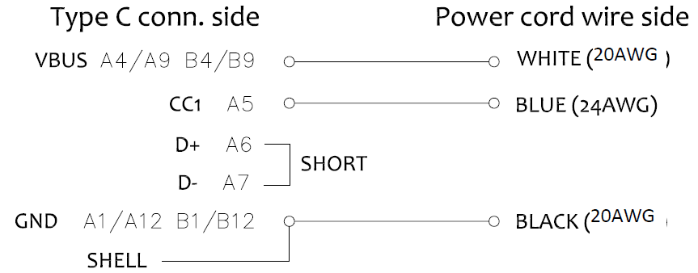
  - Adapter Weight:
MODEL LIST | Weight
ADP-65ZW BNA | 204.3g±2.5%

Mechanical characteristics
 | Item | Conditions | Specification
1. | Cord flexibility test(Delta spec) | Hang the specified weight and swing it to one direction and return to the original position then swing to the opposite direction and return to the original position. This constitutes one cycle. The DC power supply shall be subjected to the specified cycles a specified speed.  - Weight: 200g  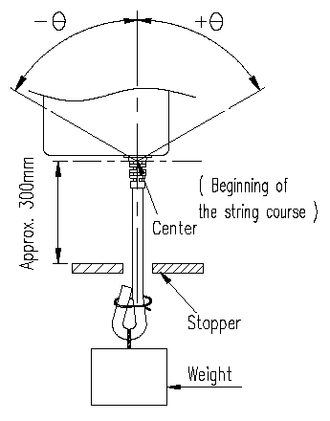  - Swing angle (θ): 0 ~ 180°  - Cycles: 1000,3000,10000cycles  - Speed: 40 cycles/min.  - Compliance: case SR, Plug SR | Disconnection rate of the wire shall be  1000 cycles –less 10%  for Plug SR  3000 cycles – less 20%  for case SR  3000 cycles – less 30%  10000 cycles – less 100% without damage to the insulations, etc..
2. | Cord flexibility test (Customer Spec.) | Hang the specified weight and swing it to one direction and return to the original position then swing to the opposite direction and return to the original position. This constitutes one cycle. The DC power supply shall be subjected to the specified cycles a specified speed.  (If the cable is without core don’t need core SR test )  1. Weight: 200g  2.Swing angle (θ): +/- 90°  3.Cycles: 3000, 10000 cycles  4.Speed: 40 cycles/min.  5.Compliance:  plug SR, case SR. | Disconnection rate of the wire shall be 30% or less for plug SR, core SR and 10% or less for case SR, without damage to the insulations, etc..
3. | Cord tensile test | A static load shall be applied and sustained for a period. Excessive load shall not be applied in this test, unless special request.  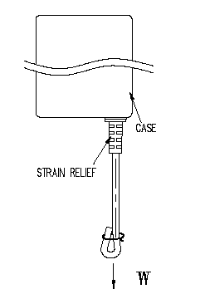  Load (w): 10 kgf  Durance: 60 sec | Contact part and bushing shall not be detached.
4. | Vibration | Non-operating, Random vibration:  5~100 Hz 0.015 G2/Hz  100~137 Hz 6 dB/oct  137~350 Hz 0.008 G2/Hz  350~500 Hz -6 dB/oct  Acceleration: 2.09 Grms  Duration: 20 min.  Direction: X,Y,Z | 1. PSU must operate with specification after non-operation test.  2. PSU shall be no mechanical damage after test.
5. | Shock | Non-operating  1. Pulse: Half sine wave.  2. Peak acceleration: 50 G  3. Duration: 11 ms  4. Number of shock: 1 shock per each direction, 6 directions. | 1. PSU must operate with specification after non-operation test.  2. PSU shall be no mechanical damage after test.

 | Item | Conditions | Specification
6. | Drop test  (with outline label) | 1. Operating  a. The drop height: H= 76 cm.  b. The drop orientation: 6 face for each.  c. Power on | 1. ATS function Pass.  2. No PWB copper pad peeling and broken.  3. No soldering crack. 4. No component broken..  5. Hi-pot test pass with specific condition. 6. Test Finger can’t touch the Hazardous Voltage of the product.
6. | Drop test  (with outline label) | 2. Non-operating  a. Drop height: H= 110 cm.  b. The drop orientation: 6 face for each.
6. | Drop test  (with outline label) | 3. Low height drop  Drop TIMES: 130 times for every surface (six side), 780 times in total.  Test surface material : The concrete  Drop height: 10cm
6. | Drop test  (with outline label) | 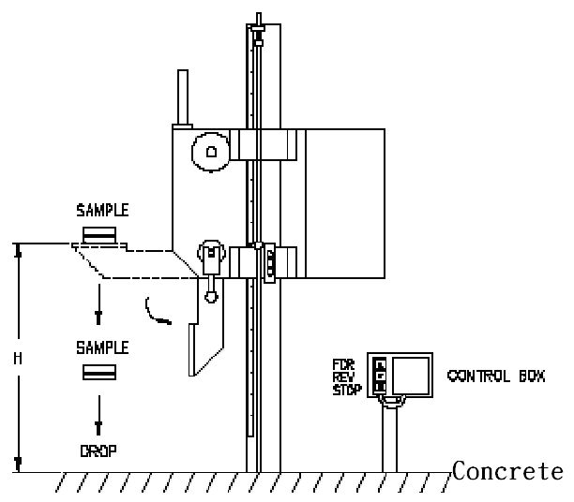  4. Equipment:

 | Item | Conditions | Specification
7. | Ball impact  (with outline label) | 1. Steel ball: 0.54 kgf .  2. Drop height: 30 cm.  3. A horizontal surface of laminated wood of hardwood at least 13mm  thick, mounted on two layers of plywood each 19mm to 20mm thick,  all supported on a concrete floor.  4. Impact location: Classify according to DUT’s dimension. LxWxH  L+W <150 B,D,F,H,I,K  150<L+W <200 A,C,D,E,G,H,I,J,K,L  200<L+W A,B,C,D,E,F,G,H,I,J,K,L  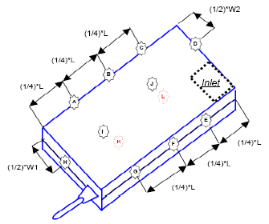  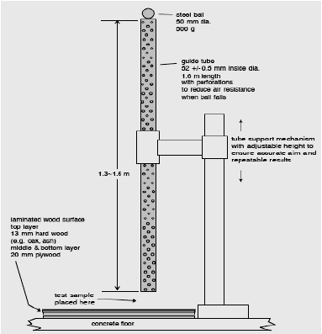  5. Equipment: | 1. Hi-pot test pass with specific condition.  2. Test Finger can’t touch the Hazardous Voltage of the product.
8. | AC Inlet Bending(I) | 1. Bending angle 15 °for either side.  2. Bending speed 10 times per minute.  3. Must withstand 30 times totally.  Equipment:  Arm controller: Delta.  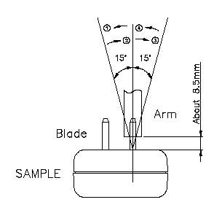 | 1. The blade can’t be any crack or damage.  2. This test refers to JIS C8303 requirement.
9 | AC Inlet Bending(II) | 1. Bending angle 30 °for either side.  2. Bending speed 10 times per minute.  3. Must withstand 5 times totally.  Equipment:  Arm controller: Delta.  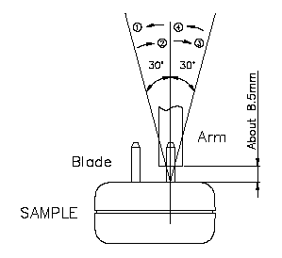 | 1. The blade can’t be any crack or damage.  2. This test refers to JIS C8303 requirement.
10 | Push Force | Push one side blade to touch another side. The force must over 4.08kgf.  Equipment:  Push-Pull force measurement controller ( 50kgf )  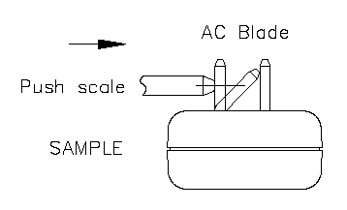 | No electrical or mechanical problem happened and no abnormity found in the shape.
11 | Load Weight | A static load 351b (15.9kg) / 2min for both pin to downside.  Equipment:  Load weight controller: Delta.  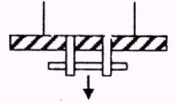 | No electrical or mechanical problem happened and no abnormity found in the shape.
12 | Push Blade | Push both pin to inside that must withstand 20kgf / 1 min.  Equipment:  Push-pull force measurement controller ( 50kgf )  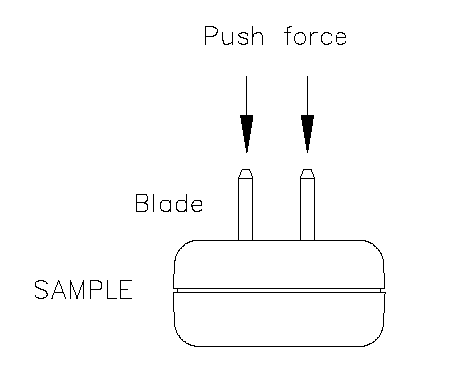 | No electrical or mechanical problem happened and no abnormity found in the shape
13 | Side Thrust | External enclosures are subjected to a steady force 12.2kg (120N) for a period of 60 sec.  Sample: 2pcs  Test point: feature of product end.  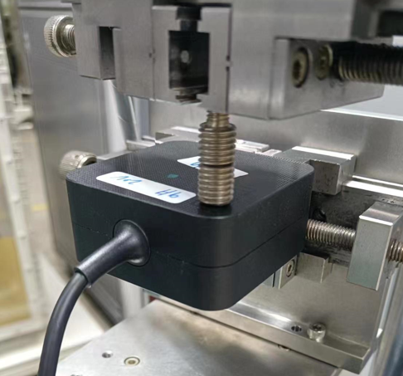  55mm  Equipment:  拉伸試驗儀 | At worst case condition, there are no damage on plastic case and socket and MUST keep the minimum safety distance 5.0mm
14 | Packing Test | Drop Test: Drop height is 350mm, testing method refers to 10000-0089  Vibration Test: Testing method refers to 10000-0089 | After test, the product should be no abnormal function and broken appearances.

Product Applications: Notebook
Product Ingress protection(IP) rating: Not requirement

